|  |  |
| --- | --- |
| P R E S S   R E L E A S E FOR IMMEDIATE RELEASE | |
| Contact: CST Covers, Grace Ferretti, Phone: 713.560.5531 |

**CST Designs and Fabricates Entry Canopy for First Net Zero Public Safety Building in the Country**

Salt Lake City Utah’s Public Safety Building is the first net-zero public safety building in the country generating as much energy as it uses.  The new facility isgetting a lot of national and even international attention.  Bringing form and function together, the 175,480-square-foot Public Safety Building will house about 276 police employees, 69 emergency dispatchers, 38 fire employees and four workers with the emergency management division.

CST Covers designed and fabricated the entry canopy for the building.  Utilizing all aluminum framing and photovoltaic glass contributed to the sustainable design concept.  The project's design team at GSBS Architects utilized photovoltaics (PV) throughout the overall project, 22,000 square foot on the roof and even more off site. The leaf-shaped canopy has 3,000 square feet of the PV panels.

The aluminum entry canopy adds signature to the pedestrian friendly courtyard. In its curved graceful form, the 175' long canopy stretches from the building's front entrance onto the public plaza. The canopy not only provides an obvious point of entrance to the 4-story building but also shades part of the plaza. The canopy generates about 30 KV of electricity from the PV cells.

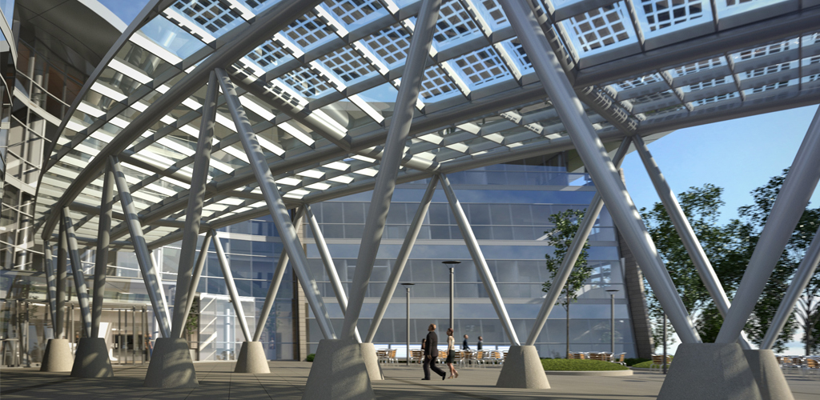

CST Covers is the worldwide leader in the design, manufacture and construction of custom aluminum covers and structures for architectural, environmental and industrial applications.

CST Covers has supplied over 16,000 covers in more than 90 different countries and offers multiple structural, high strength aluminum design solutions including domes, vaults, extruded flat covers, formed flat panel covers, truss supported covers, space frames as well as custom products specifically designed for customers unique vertical and overhead applications.

The company maintains manufacturing facilities and technical design centers in Gardena, California; Conroe, Texas; and Rincon, Georgia. The company is headquartered out of the Conroe, TX location.

For more information, contact Kim Reeves, Global Marketing Director, CST Industries at +1.713.351.3769.